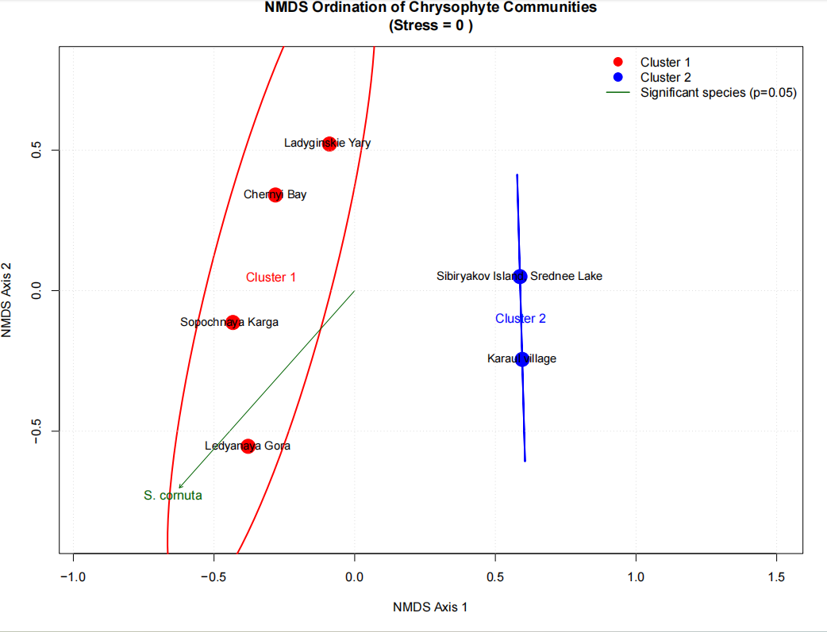
Figure 1: NMDS 2 Clusters
From the above figure we can see that:

Cluster 1 (red): Ladyginskie Yary, Chernyi Bay, Sopochnaya Karga, and Ledyanaya Gora.

Cluster 2 (blue): Sibiryakov Island–Srednee Lake and Kara Village.

The clear separation along NMDS Axis 1 shows that chrysophyte communities in Cluster 1 are markedly different from those in Cluster 2. The black vector for Synura cornuta (S. cornuta) indicates this species is a major driver of the between-site differences. Finally, a stress value of 0 denotes an excellent ordination fit, meaning the plot faithfully represents the relationships among samples.

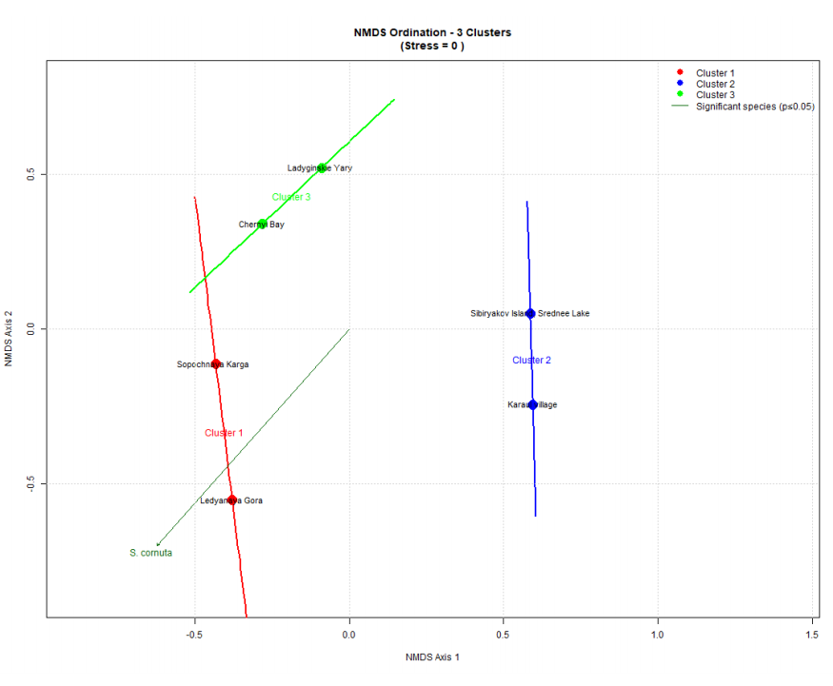
Figure 2: NMDS 3 Clusters
From the above figure we can see that:

Cluster 1 (red): Sopochnaya Karga and Ledyanaya Gora.

Cluster 2 (blue): Sibiryakov Island–Srednee Lake and Kara Village.

Cluster 3 (green): Ladyginskie Yary and Chernyi Bay.

This pattern indicates that Ladyginskie Yary and Chernyi Bay have sufficiently distinct community compositions to form their own cluster, separate from the other red sites. The prominent species vector for S. cornuta continues to point toward the lower-left, showing its association with sites in that direction. A stress value of 0 again indicates the ordination reliably represents the community similarity relationships.

